AI Application Architecture
User → Frontend → Backend → LLM API → Response
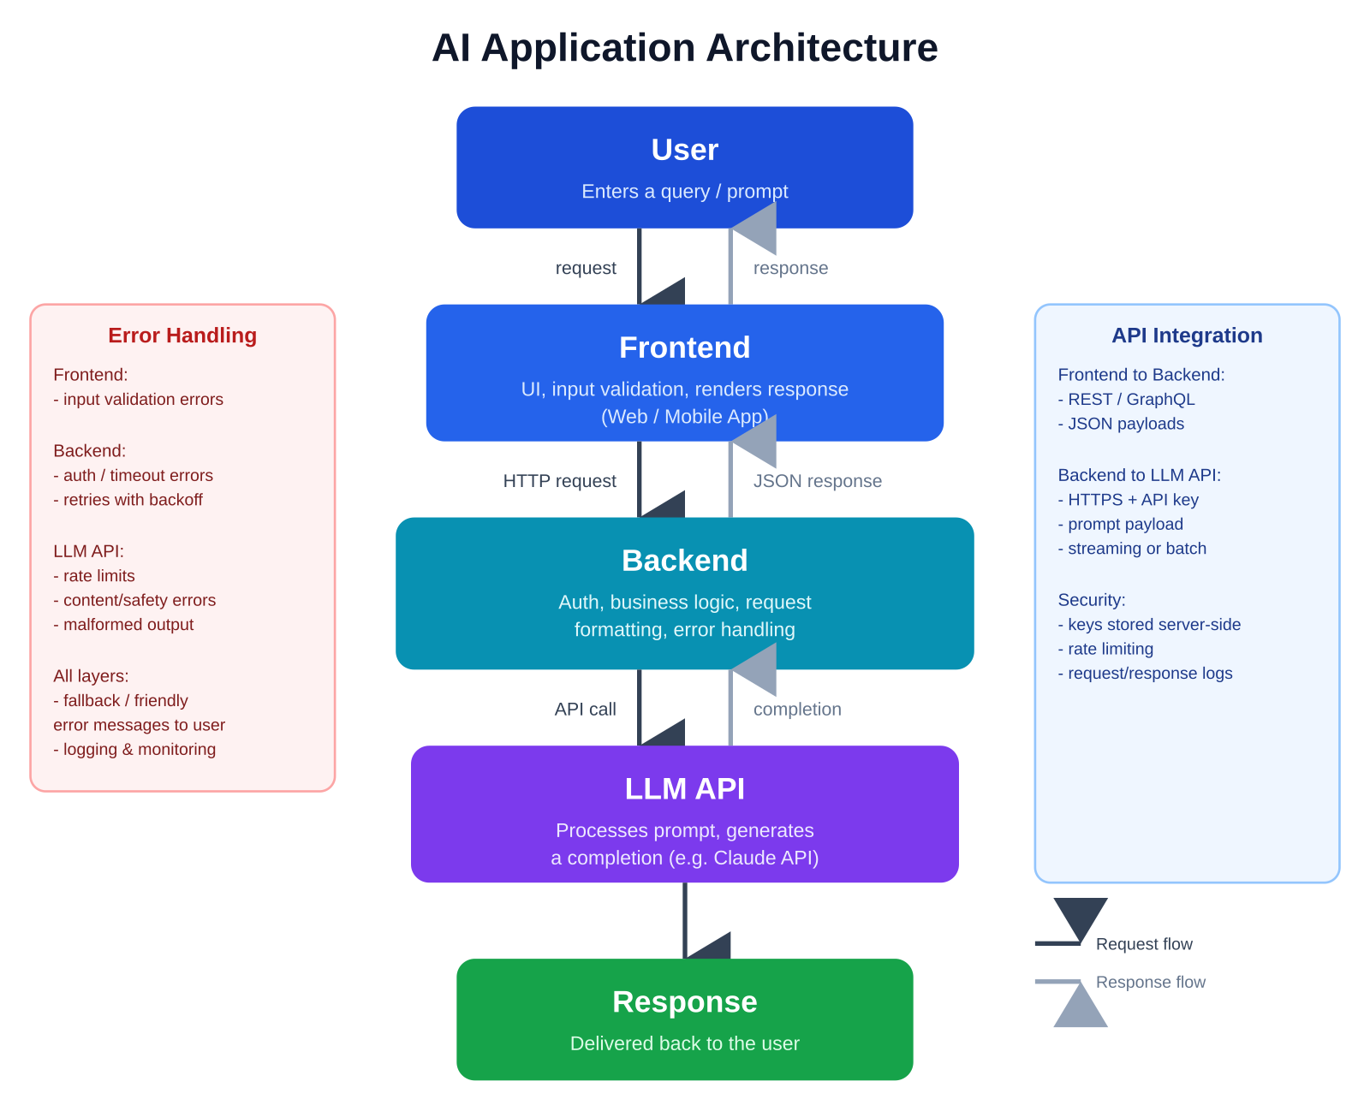

Request Flow
- The User submits input (a query or prompt) through the Frontend interface.
- The Frontend validates the input and sends it as an HTTP request (REST/GraphQL, JSON payload) to the Backend.
- The Backend authenticates the request, applies business logic, and formats a prompt payload for the LLM API.
- The Backend calls the LLM API over HTTPS using a securely stored API key.

Response Flow
- The LLM API processes the prompt and generates a completion (text, structured data, etc.), returned as streaming or batch output.
- The Backend receives the completion, applies any post-processing (formatting, filtering, business rules), and returns a JSON response to the Frontend.
- The Frontend renders the response for the User to view.

Error Handling
- Frontend: validates input before sending and displays friendly messages for network or validation errors.
- Backend: handles authentication failures, timeouts, and LLM API errors; retries transient failures with backoff before failing gracefully.
- LLM API layer: surfaces rate-limit, content-safety, or malformed-output errors, which the Backend catches and translates into safe, user-readable messages.
- All layers log errors for monitoring and debugging, while ensuring the User only sees clear, actionable feedback rather than raw stack traces.

API Integration
- Frontend ↔ Backend: typically a REST or GraphQL API exchanging JSON payloads over HTTPS.
- Backend ↔ LLM API: an HTTPS call (e.g., to the Claude API) carrying the prompt, model parameters, and authentication (API key), supporting streaming or batch responses.
- Security best practices: API keys are stored and used only on the Backend (never exposed to the Frontend), requests are rate-limited, and requests/responses are logged for observability.

